# Robot Design Executive Summary (RDES) – The Super Squirrels 23229

## Robot Facts

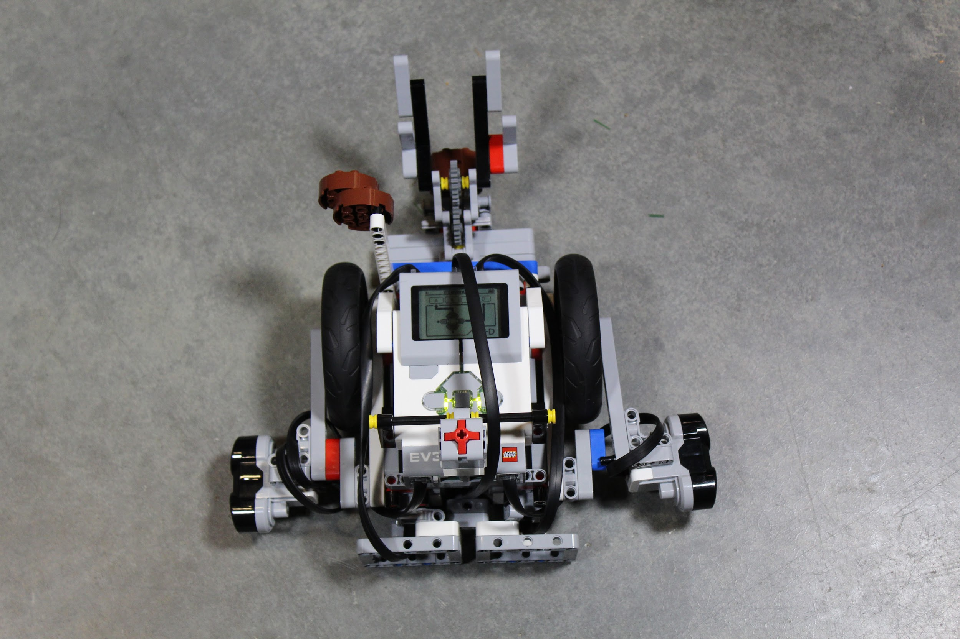

Meet Eleven, she has many sensors to help us solve problems quickly and effectively. In all, we have -

* two ultrasonic sensors
* one touch sensor
* one gyro sensor
* two large motors
* two large wheels
* a steel ball
* medium motor

We have 3 main attachments on our robot. The first attachment is for the fountain challenge which is a large scoop where we hold the big water. That attachment is also used for the pipe removal challenge.The scoop lowers the big water into the fountain. The second attachment is used in the filter challenge. It is an Animal Allies penalty brick connected to an axle. All our attachments connect from a shared point on our robot to simplify removing and reattaching attachments.

Strategy:

Our team evaluated missions on three criteria; proximity to base, ease of completion, and points given. Challenges that were closer to base, were easier to complete, and were worth high amounts of points are marked as high priority challenges. From that list we chose the challenge that intrigued us the most. We based all challenge selections before this initial selection on the same criteria, but instead of the distance between the base and the robot we looked at distance to our first selected challenges.

### Design Process:

### Our robot had many phases in the beginning including multiple rebuilds. Our first phase started out as a drawing that was a box on wheels. The execution of this idea was not as simple as the concept sounded and after evaluating the amount of time that actual execution of this concept would cost the team, it was scrapped. From there we decided to focus on the same criteria as the box on wheels idea (simplicity and sturdiness) but with the added criteria of ease of building. However, our initial execution was far too complex and included to many non-essential components. Our final design was actually a revision of the second robot, where we focused on identifying and removing the non-essential components. For example, we removed the holey-beams that appeared to connect the EV3 brick to the chassis, but in reality were only decorative pieces. However, our revisions did not only consist of removal of non-essential pieces, they also consisted of general improvements. One of this improvements was the attachment of reinforcement pieces that ensured that the wheels of the robot were incapable of turning to ensure that the robot drove straight (or at least it never drove crookedly at the fault of its own wheels).

### All the team members contributed through group brainstorm sessions we had. For example, we sketched out a basic robot design and edited it as a group. We then brought this idea to life by building prototypes of our designs. Then, we had more brainstorming ideas to improve the design. We did this until we were satisfied with the design. We sometimes scrapped entire robot builds because no matter how much we edited them, they were consistently unsuccessful.

### Mechanical Design:

Eleven’s design consists of a simple chassis, thin wheels with a high diameter to increase the distance covered per rotation and the stability of the robot, and two large motors placed beneath the EV3 brick to build upon the simplistic composure of our robot. All sensors have been permanently attached as each one is used in each challenge. The touch sensor was placed in the most easily accessible spot we could think of to add to the ease off running the challenges created initially by our ultrasonic sensor start code Our robot has an entirely flat back to provide a flat surface for the pump addition challenge and any future wall squaring without the addition of a new attachment.

Programming:

Our programming style is centered around understandability and accuracy. Code was not only tested for ability to complete the task at hand, it was also tested to ensure that it was in its simplest possible form. Combined with comment blocks that were included to describe the task that each block of code was there to do, this created code that could be understood and edited by any member of the team. Before we started programming ours runs, we coded several basic blocks to be reused in later programs, including a wall squaring code (which relies on of our robot’s posterior touch sensors), and wall following code (reliant on our robot’s ultrasonic sensor). Many pieces of code had to be simplified (especially the wall squaring code which initially included interpretation of three different touch sensor states and now includes only interpretation of the one necessary state).

### Innovation:

### The most unique feature of our robot is the fact that instead of our challenges being controlled by manually going into the robot and selecting both our setup code and then selecting the project code itself, we have developed a block that allows both the setup code and the challenge code itself to be run simultaneously. This block requires two inputs - the minimum and maximum possible ultrasonic sensor values that can be true while the robot is in a starting position that will allow it to successfully complete the mission at hand, and is capable of using on screen text (reading “move left” or “move right”) to direct whoever is setting up the robot to a location at which the values are true. When the robot is in a location in which the values are true, the on screen displays “start!” or a similar message, thus alerting whomever is setting the robot up that it is now okay to start. The way that the handler starts the robot is the where the real innovative genius lies within this aspect of our robot. Instead of ending the setup program and finding the next program to run within the robot, the handler simply presses the touch sensor located at the top of our robot, and then the proper mission runs. Starting the next mission is literally as simple as pressing a button thanks to our robot and code.

### Another unique aspect of our robot is our motor placement. We have two large motors tightly placed under the robot upside down. This created more space for other pieces such as our medium motor that powers most of our attachments. Another special characteristic of our robot that our attachment is uniquely connected to the robot, our connection system consists of our axles protruding from the front of the robot. This is different because it is attached in one central position rather than multiple places across the robot and is a vital part of our robot’s performance in the mission.

### Fun:

### Our favorite part of the robot is the Big Water attachment because it was the first attachment that we completed. Our motor for the attachment is in the front of the robot near the ground. Our color sensor was in a difficult position to work around with the attachment. So, we attached the attachment about 3 inches from the robot, so we didn’t have to work around anything. This attachment works 60% of the time.